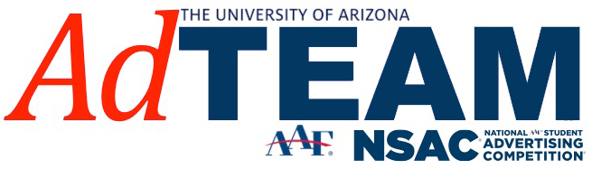

Name:

GPA:

Year in School:

Major:

Minor (If Applicable):

***This application are for candidates interested in the AdTEAM’s NSAC Competition Team***

How did you hear about AdTEAM’s NSAC Competition Team?

What can you contribute to the NSAC Team?

Please include any skills or experience that can strengthen the team as a whole

Why do you want to be a member of NSAC?

**Application Deadline is due February 9th, 2018**

Please return the application, resume, and cover letter to:

[Adteamua@gmail.com](mailto:Adteamua@gmail.com)